**ANONYMIZING DATA FROM GIVEN SAMPLE DATA (PATIENT ID only)**

**NOTE- The following document is divided in three parts.**

Part-1 Anonymizing Patient ID from given sample data.

Part-2 Error in the files not Anonymized.

Part-3 Reading the dcm images and data.

**PART-1**

* Download the zip file and extract it.
* Copy all the images in a folder (which are currently in different folders 1,2,3…)
* Create a python file anonymize.py inside the same folder, which contains the code to anonymize the patient ID of all dcm images placed within the same folder.

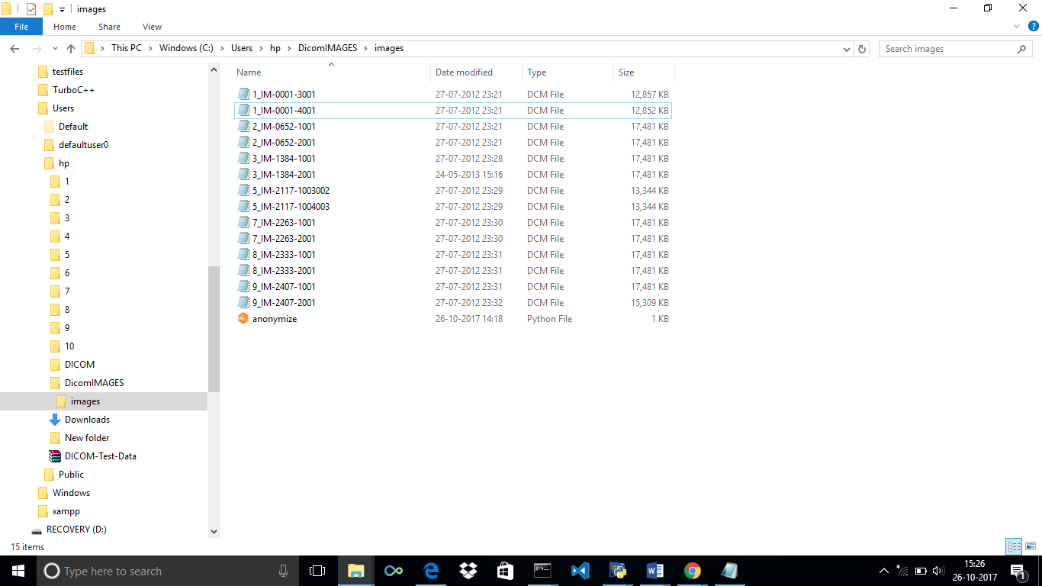

* Creating anonymize.py :-

Code-

import dicom

import glob

import os, sys

from os.path import join, expanduser

dicomPath = sys.argv[0]

for file in glob.glob("*.dcm"):

print("### Now reading file:", file)

df = dicom.read_file(file,'rb')

print(file)

df[0x10,0x20].value="XXXX";

print(df[0x10,0x20]).value

df.save_as("modified"+file);

print("end")

* Open command prompt and go to the location where the above images and file is placed:-

C:\Users\hp\DicomIMAGES\images>python anonymize.py

* OUTPUT-

('### Now reading file:', '1_IM-0001-3001.dcm')

1_IM-0001-3001.dcm

XXXX

('### Now reading file:', '1_IM-0001-4001.dcm')

1_IM-0001-4001.dcm

XXXX

('### Now reading file:', '2_IM-0652-1001.dcm')

2_IM-0652-1001.dcm

XXXX

('### Now reading file:', '2_IM-0652-2001.dcm')

2_IM-0652-2001.dcm

XXXX

('### Now reading file:', '3_IM-1384-1001.dcm')

3_IM-1384-1001.dcm

XXXX

('### Now reading file:', '3_IM-1384-2001.dcm')

3_IM-1384-2001.dcm

XXXX

('### Now reading file:', '5_IM-2117-1003002.dcm')

5_IM-2117-1003002.dcm

XXXX

('### Now reading file:', '5_IM-2117-1004003.dcm')

5_IM-2117-1004003.dcm

XXXX

('### Now reading file:', '7_IM-2263-1001.dcm')

7_IM-2263-1001.dcm

XXXX

('### Now reading file:', '7_IM-2263-2001.dcm')

7_IM-2263-2001.dcm

XXXX

('### Now reading file:', '8_IM-2333-1001.dcm')

8_IM-2333-1001.dcm

XXXX

('### Now reading file:', '8_IM-2333-2001.dcm')

8_IM-2333-2001.dcm

XXXX

('### Now reading file:', '9_IM-2407-1001.dcm')

9_IM-2407-1001.dcm

XXXX

('### Now reading file:', '9_IM-2407-2001.dcm')

9_IM-2407-2001.dcm

XXXX

end

**The folder now contains the anonymized patient Id dcm file with Prefix modified added in file name: -**

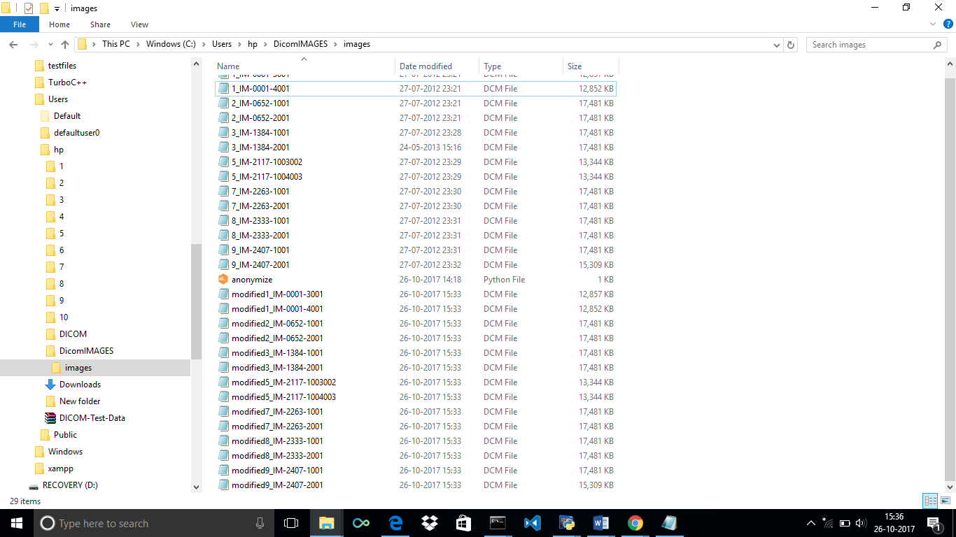

* Go to python.exe to see the anonymized PATIENT ID: -
* We will check first the ID before Anonymized and then after it.

**Before-**

* Write the following command in Python.exe-

**>>> ds=dicom.read_file("C:/users/hp/DicomIMAGES/images/8_IM-2333-2001.dcm",'br')**

**>>> ds.dir**

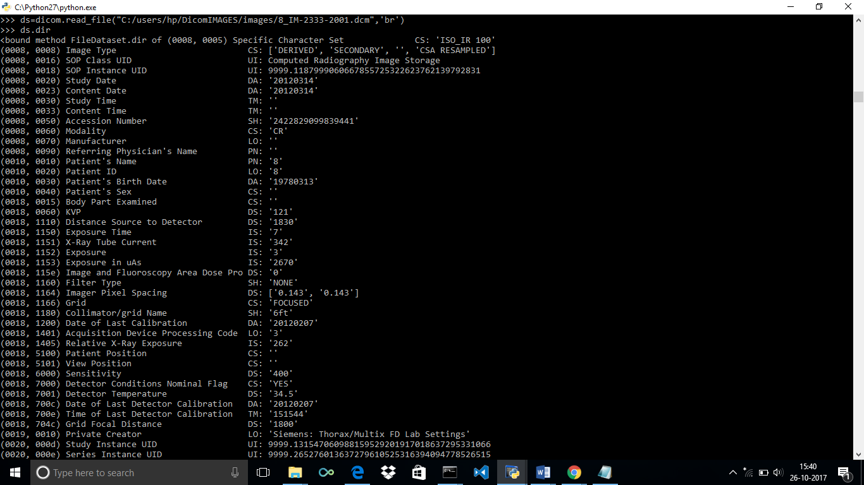

Taking few data here-

(0008, 0070) Manufacturer LO: ''

(0008, 0090) Referring Physician's Name PN: ''

(0010, 0010) Patient's Name PN: '8'

(0010, 0020) Patient ID LO: '8'

(0010, 0030) Patient's Birth Date DA: '19780313'

After-

**>>> ds=dicom.read_file("C:/users/hp/DicomIMAGES/images/modified8_IM-2333-2001.dcm",'br')**

**>>> ds.dir**

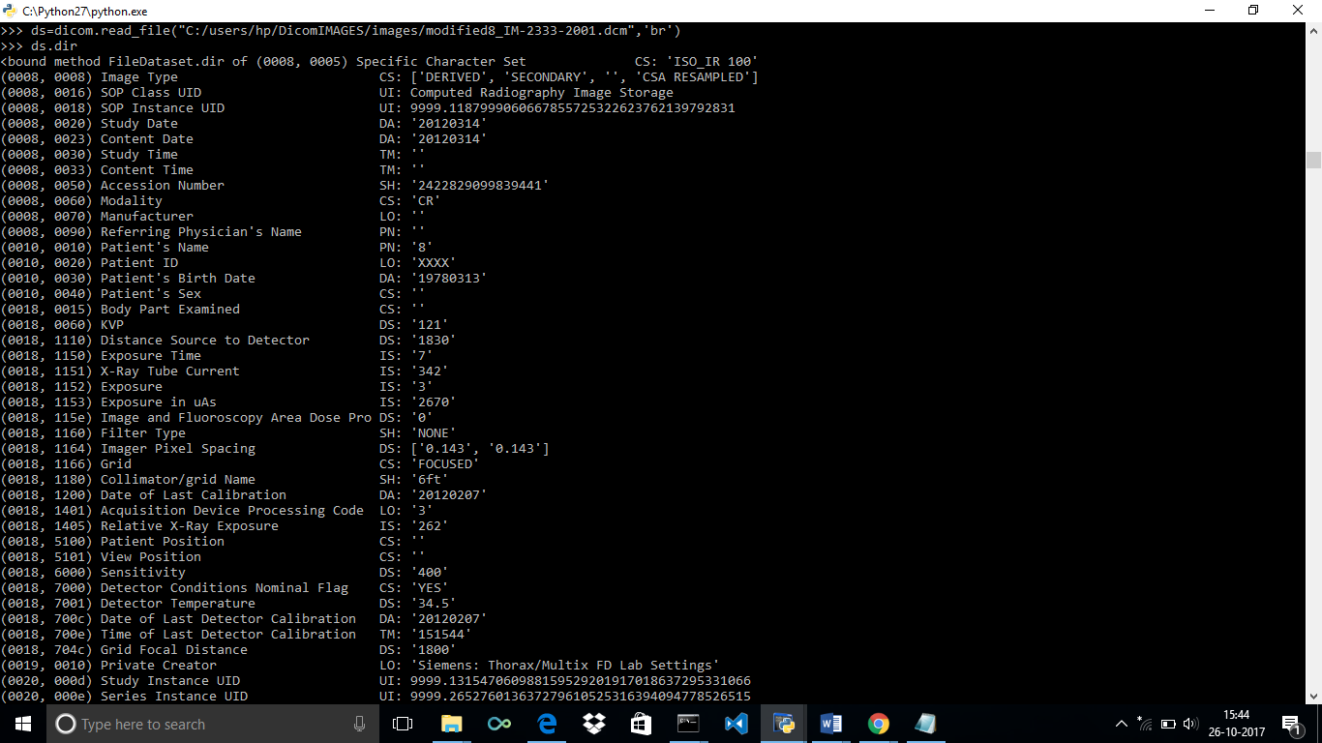

* (Taking few data here)

(0008, 0070) Manufacturer LO: ''

(0008, 0090) Referring Physician's Name PN: ''

(0010, 0010) Patient's Name PN: '8'

(0010, 0020) Patient ID LO: 'XXXX'

(0010, 0030) Patient's Birth Date DA: '19780313'

(0010, 0040) Patient's Sex CS: ''

(0018, 0015) Body Part Examined CS: ''

Similarly, we can see for different images also.

**PART -2**

ERROR in 6 images-

These are the 6 images (which are placed inside folders 4,6,10 inside the zip.)

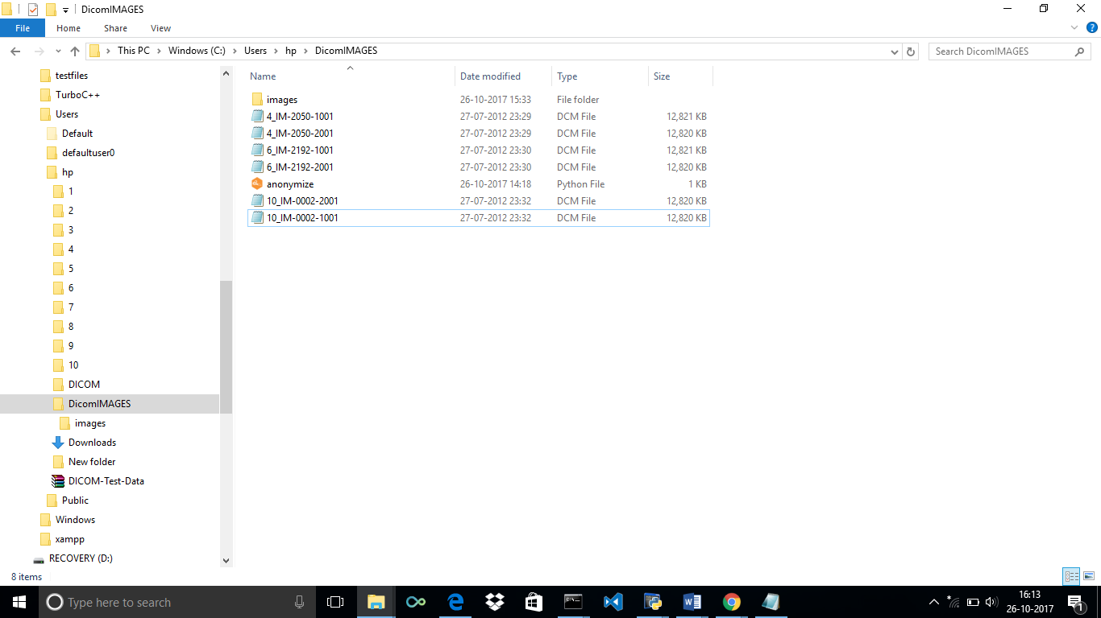

This is the error while just reading these 6 files-

**>>>ds=dicom.read_file("C:/users/hp/DicomIMAGES/10_IM-0002-2001.dcm",'br')**

**>>> ds.dir**

Traceback (most recent call last):

File "<stdin>", line 1, in <module>

File "C:\Python27\lib\site-packages\pydicom-0.9.8-py2.7.egg\dicom\dataset.py", line 514, in __str__

return self._pretty_str()

File "C:\Python27\lib\site-packages\pydicom-0.9.8-py2.7.egg\dicom\dataset.py", line 446, in _pretty_str

strings.append(dataset._pretty_str(indent + 1))

File "C:\Python27\lib\site-packages\pydicom-0.9.8-py2.7.egg\dicom\dataset.py", line 441, in _pretty_str

for data_element in self:

File "C:\Python27\lib\site-packages\pydicom-0.9.8-py2.7.egg\dicom\dataset.py", line 315, in __iter__

yield self[tag]

File "C:\Python27\lib\site-packages\pydicom-0.9.8-py2.7.egg\dicom\dataset.py", line 285, in __getitem__

self[tag] = DataElement_from_raw(data_elem, character_set)

File "C:\Python27\lib\site-packages\pydicom-0.9.8-py2.7.egg\dicom\dataelem.py", line 340, in DataElement_from_raw

raise NotImplementedError("{0:s} in tag {1!r}".format(str(e), raw.tag))

NotImplementedError: Unknown Value Representation 'US or OW' in tag (0028, 3006)

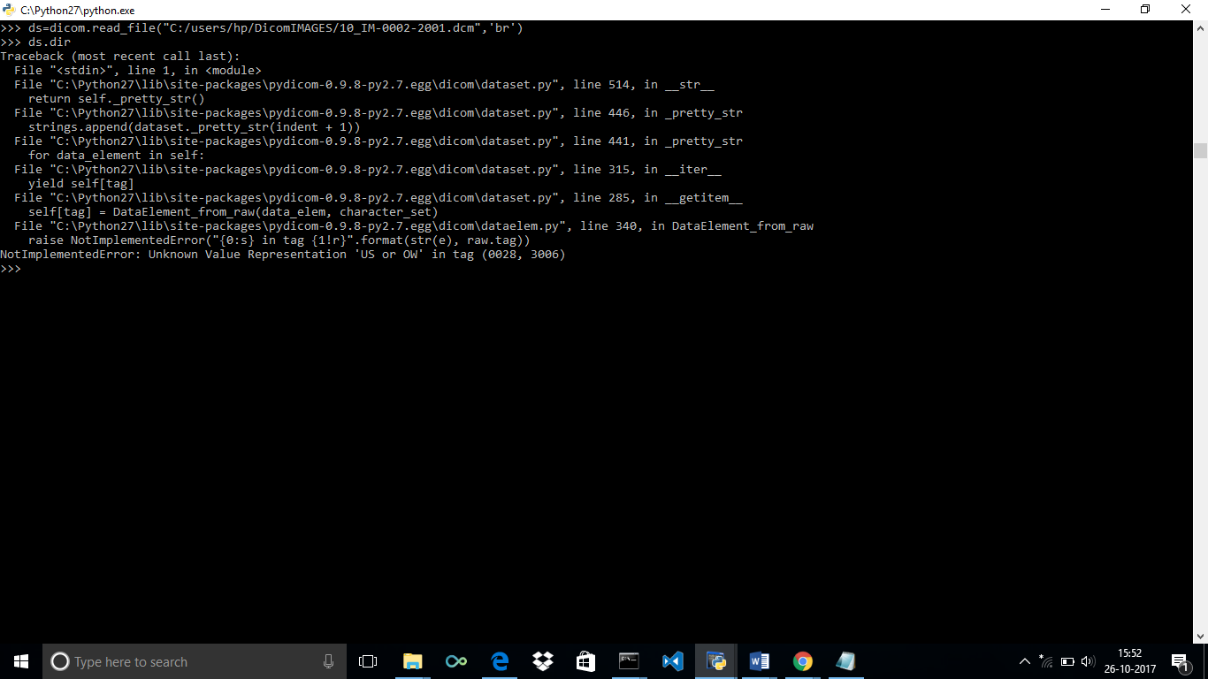

**ERROR**

While executing the anonymize python file.

C:\Users\hp\DicomIMAGES>python anonymize.py

('### Now reading file:', '10_IM-0002-1001.dcm')

10_IM-0002-1001.dcm

XXXX

Traceback (most recent call last):

File "anonymize.py", line 12, in <module>

df.save_as("modified"+file);

File "C:\Python27\lib\site-packages\pydicom-0.9.8-py2.7.egg\dicom\dataset.py", line 467, in save_as

dicom.write_file(filename, self, WriteLikeOriginal)

File "C:\Python27\lib\site-packages\pydicom-0.9.8-py2.7.egg\dicom\filewriter.py", line 344, in write_file

write_dataset(fp, dataset)

File "C:\Python27\lib\site-packages\pydicom-0.9.8-py2.7.egg\dicom\filewriter.py", line 196, in write_dataset

write_data_element(fp, dataset[tag], dataset_encoding)

File "C:\Python27\lib\site-packages\pydicom-0.9.8-py2.7.egg\dicom\filewriter.py", line 160, in write_data_element

writers[VR](fp, data_element, encoding=encoding)

File "C:\Python27\lib\site-packages\pydicom-0.9.8-py2.7.egg\dicom\filewriter.py", line 207, in write_sequence

write_sequence_item(fp, dataset, encoding)

File "C:\Python27\lib\site-packages\pydicom-0.9.8-py2.7.egg\dicom\filewriter.py", line 217, in write_sequence_item

write_dataset(fp, dataset, parent_encoding=encoding)

File "C:\Python27\lib\site-packages\pydicom-0.9.8-py2.7.egg\dicom\filewriter.py", line 196, in write_dataset

write_data_element(fp, dataset[tag], dataset_encoding)

File "C:\Python27\lib\site-packages\pydicom-0.9.8-py2.7.egg\dicom\dataset.py", line 285, in __getitem__

self[tag] = DataElement_from_raw(data_elem, character_set)

File "C:\Python27\lib\site-packages\pydicom-0.9.8-py2.7.egg\dicom\dataelem.py", line 340, in DataElement_from_raw

raise NotImplementedError("{0:s} in tag {1!r}".format(str(e), raw.tag))

NotImplementedError: Unknown Value Representation 'US or OW' in tag (0028, 3006)

C:\Users\hp\DicomIMAGES>

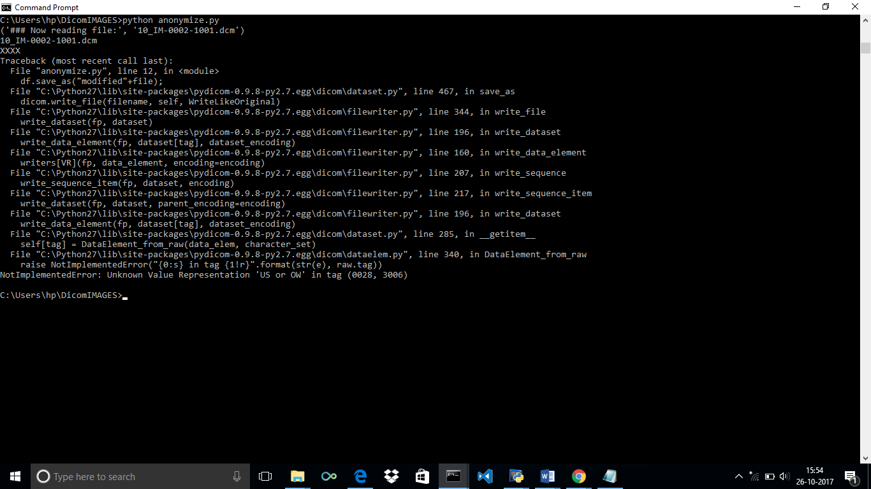

**ERROR**

**PART-3**

**READING OF IMAGES-**

* Download the zip file and extract it.
* Copy all the images in a folder (which are currently in different folders 1,2,3…)
* Go to python.exe and add the following code( or create a file and run python filename.py)

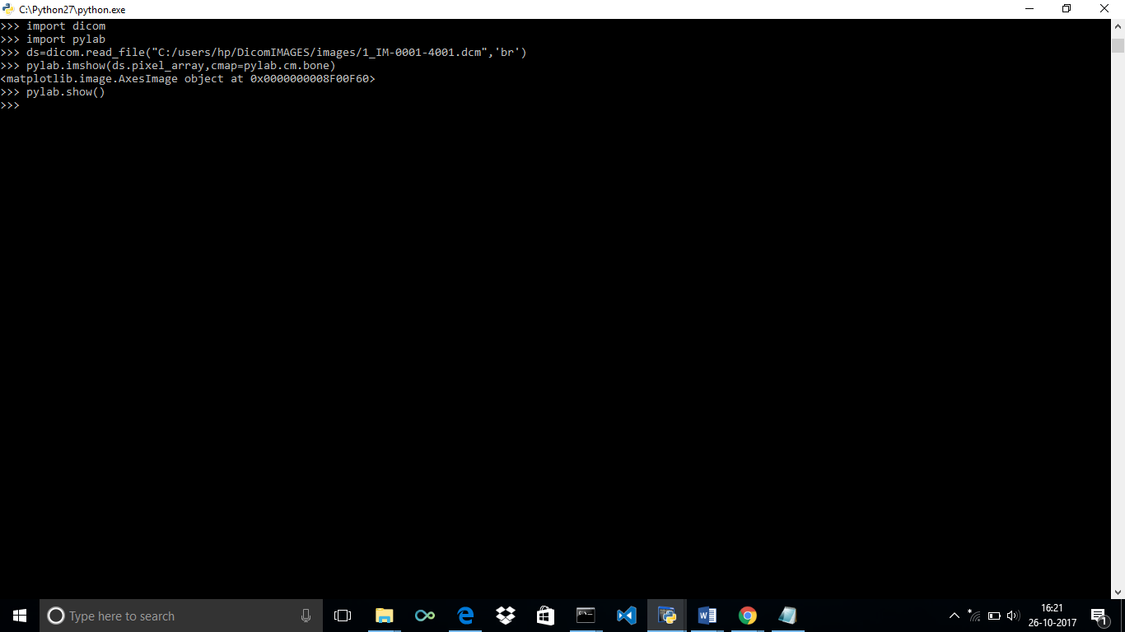

**CODE**-

>>> import dicom

>>> import pylab

>>> ds=dicom.read_file("C:/users/hp/DicomIMAGES/images/1_IM-0001-4001.dcm",'br')

>>> pylab.imshow(ds.pixel_array,cmap=pylab.cm.bone)

<matplotlib.image.AxesImage object at 0x0000000008F00F60>

>>> pylab.show()

The dcm image is read using python.

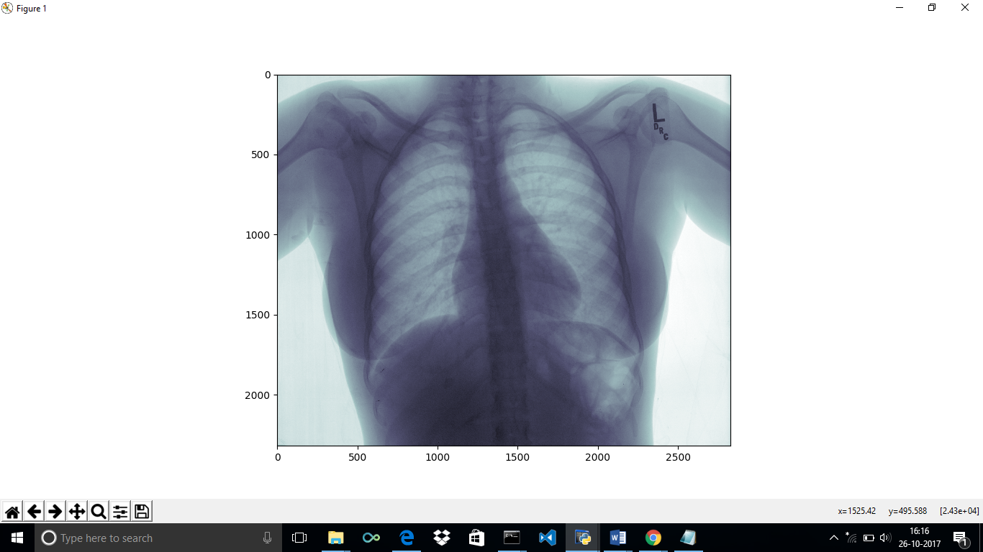

Similarly, we can read all the images.

Reading the data –

**>>> ds=dicom.read_file("C:/users/hp/DicomIMAGES/images/1_IM-0001-4001.dcm",'br')**

**>>> ds.dir**

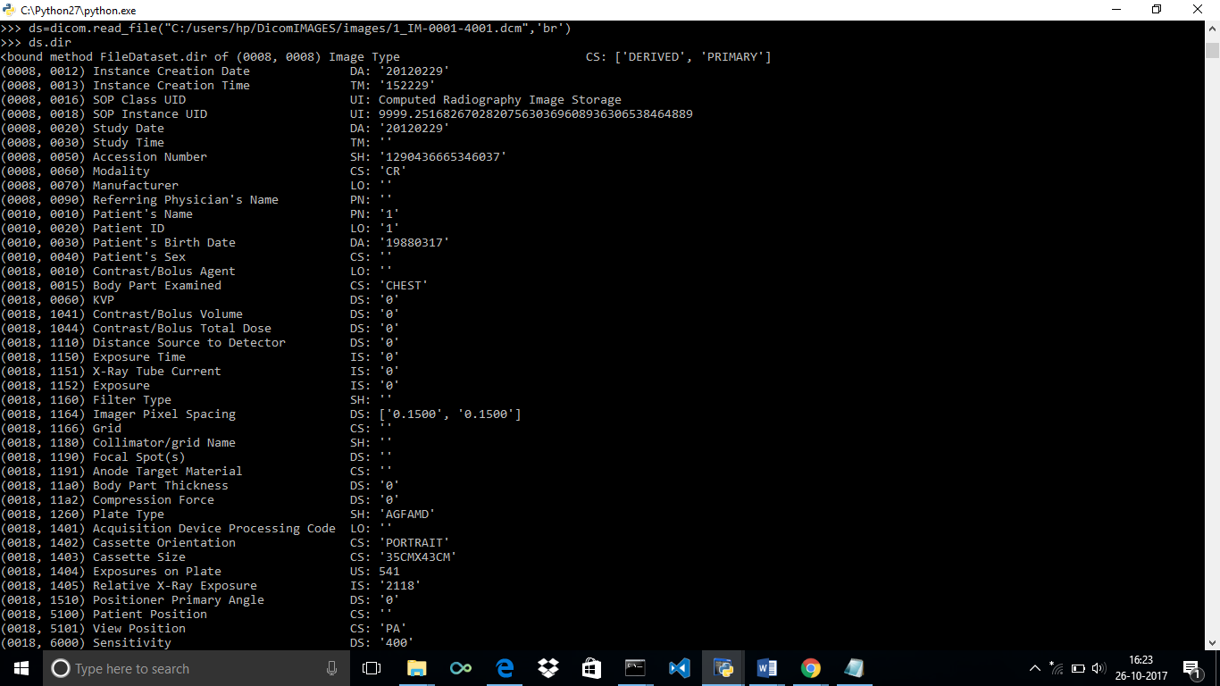

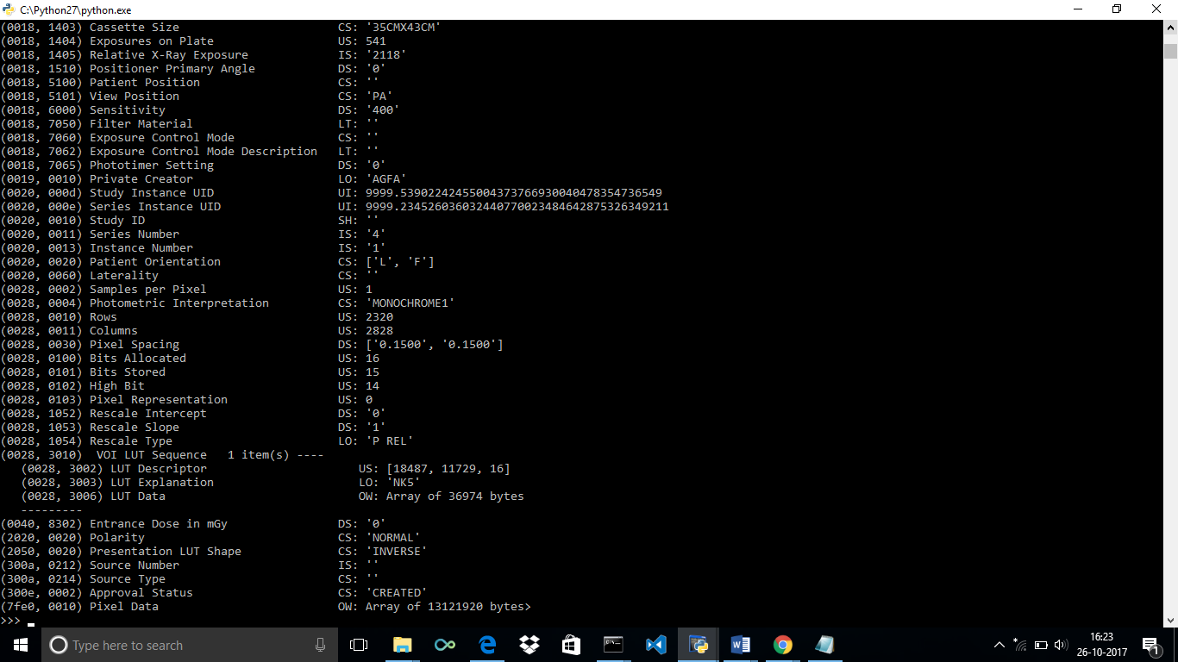

Similarly we can read all the images except those in which error is coming(6).

**Thanks**

**Vithika Gupta**